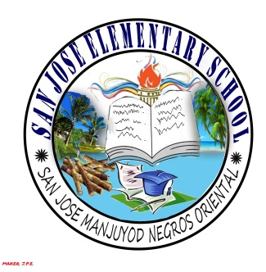
SAN JOSE ELEMENTARY SCHOOL

Manjuyod District I
Manjuyod, Negros Oriental

TEACHER'S INDIVIDUAL CLASSROOM PROGRAM
S.Y. 2015-2016
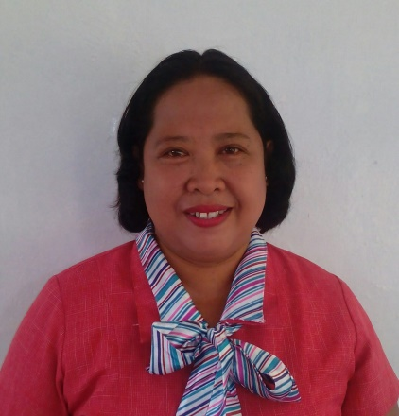

Name of Teacher: ELENA C. LLENOS
Current Position: TEACHER II
Teaching Experience (No. of years): 18
Teaching Experience (in Grade Level): 0
Birthday: 10-12-69 Age: 45
Gender: FEMALE Marital Status: MARRIED
Educational Attainment:
Course: BEED
School: Silliman University

Grade Level:
Enrolment: (Male)16 (Female)5 Total: 21

MORNING SESSION
Time | Minutes | Subject/Activities
7:30- 7:45 | 15 | Flag Raising Ceremony
7:45- 8:35 | 50 | English
8:35- 9:25 | 50 | Science
9:25- 9:40 | 15 | RECESS
9:40- 10:30 | 50 | Math
10:30- 11:00 | 30 | ESP
11:00- 11:30 | 30 | Remedial Instructions
L U N C H B R E A K
AFTERNOON SESSION
1:00-1:30 | 30 | Synchronized Reading
1:30- 2:20 | 50 | Filipino
2:20- 3:10 | 50 | AP
3:10- 3:50 | 40 | MAPEH
3:50- 4:30 | 40 | EPP
4:30-4:45 | 15 | Flag Retreat
4:45- 5:00 |  | Teacher Preparation

Ancillary Services:
English School Coordinator
GPAK School Coordinator
Science School Coordinator
ORV-English School Coordinator

ELENA C. LLENOS
Adviser

Prepared by: Approved:

VICTORIA A. BANJAO ANTONIETA C. OLORES
School Head PSDS

