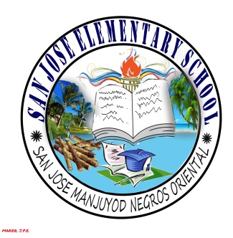
SAN JOSE ELEMENTARY SCHOOL

Manjuyod District I
Manjuyod, Negros Oriental

TEACHER'S INDIVIDUAL CLASSROOM PROGRAM
S.Y. 2015-2016

Name of Teacher:
Current Position: TEACHER II
Teaching Experience (No. of years):
Teaching Experience (in Grade Level): 0
Birthday: Age:
Gender: Marital Status:
Educational Attainment:
Course:
School:

Grade Level:
Enrolment: (Male) (Female) Total:

MORNING SESSION
Time | Minutes | Subject/Activities
L U N C H B R E A K
AFTERNOON SESSION

Ancillary Services:

Name of Adviser/Teacher

Prepared by: Approved:

Name of Principal/School Head Name of PSDS

