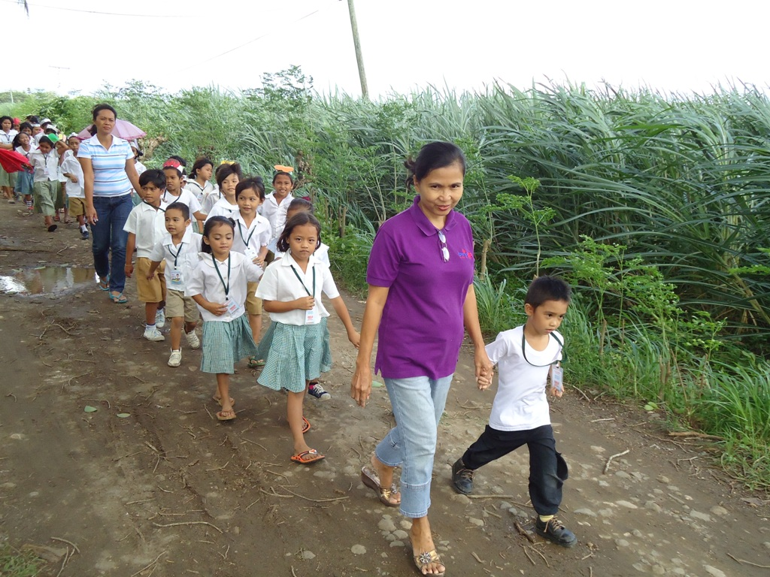The Legend of Barangay San Jose of Manjuyod

Long time ago, many places had no name. One of these places is Barangay San Jose of Manjuyod. Why is Barangay San Jose called its name.
According to Mrs. Lornita B. Academia, the Sycip family owned hectares of land in this place. The said family was so devoted to St, Joseph or known as San Jose. They had abundant harvest, So they believed that San Jose was the one who blessed them and so with the people in their place.
As their way of thanking him, every 19th day of March they had a Feast or Thanksgiving. They were very happy doing it every year.
The Livelihood of the people in the Barangay continue to prosper. Because of their faith to Sr. San Jose, the family decided to name the place San Jose to honor the said Patron. That is why the place was called Barangay San Jose.
Today, many children are able to go to school because San Jose Elementary School was newly opened. Beautiful areas can be found in this place like, riverbanks, big sugarcane plantation and others.
This is all about Barangay San Jose.

